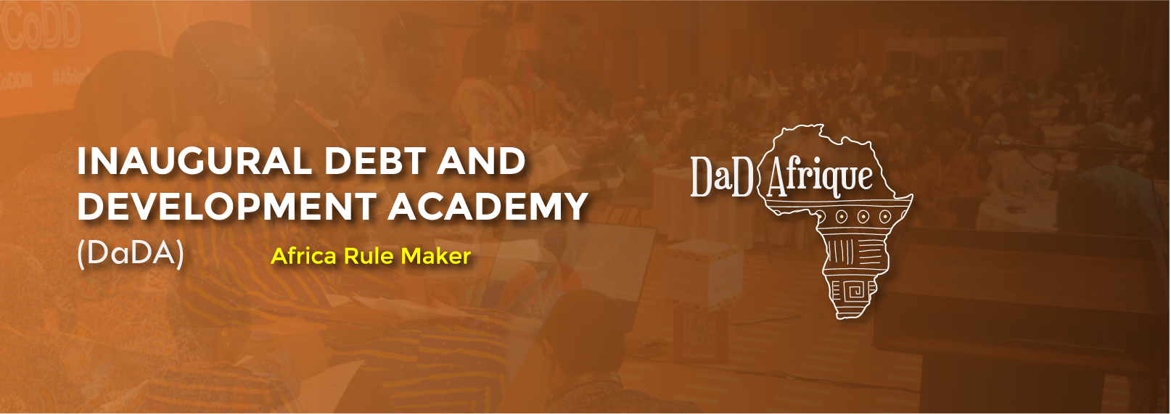
INAUGURAL DEBT AND DEVELOPMENT ACADEMY (DaDA)
PROGRAMME
2ND – 4TH OCTOBER 2023

Day 1, Monday 2nd October 2023
Arrival and Registration: 8:00am-8:30am
Opening Session: 8:30am-9:00am
Moderator- AFRODAD
Welcoming remarks
- PALU
- AFRODAD
Keynote Address
Session 1- Module 1: 9:00am -11:00am
Convener- Stephano Prato & Jane Nalunga
Title: Global Processes and the Political Economy of Debt
Purpose: The purpose of this module is to enable the participants understand the processes of the rapid debt accumulation that we have witnessed over the years, providing an analysis of the causes and evolution of public debt over the years and the deeply rooted challenges of the political economy of debt in the Africa and the global south.

Objective- to enlighten the participants on where we are coming from in terms of the political economy of debt and the resultant challenges and impacts of the current debt architecture and the need for its dismantling.

Tea/Coffee Break: 11:00am – 11.30am
Session 2- Module 2: 11.30am- 1pm
Convener- Crystal Simeoni
Title: Alternative Approaches to Debt
Purpose: The purpose of this module is to unpack the different emerging approaches to debt as it evolves with particular focus on the neoliberal/neocolonial approach and the feminist approach based on the impact that debt has on human rights, especially on the rights of women and girls.

Objective- The objective of this module is to unpack the various approaches to debt are critical in the comprehension of the macroeconomic dimension of inequalities besides the microeconomic implications of debt.

Lunch Break: 1pm-2pm
Session 3- Module 3: 2pm-3.30pm
Convener- Joab Okanda
Title: Influencing Institutions
Purpose: This module seeks to enlighten the participants on how major institutions in Africa work and their processes.

Objective: The objective of this module is to help participants understand the key moments, why we need to influence these institutions and how to go about it.

END OF DAY ONE!!!
Day 2, Tuesday 3rd October 2023
Arrival and Registration: 8:30am-9:00am
Thematic Areas Around Debt: 9am- 5pm
This module will focus on connecting debt as there are many interfaces between debt and trade, tax, climate as well as looking into the legal aspects of debt that need to be singles out as they are crucial due to the multidimensional aspect of debt.
Session 4-Module 4: Thematic Area 1: 9:00am-10:30am
Convener – AFRODAD
Title: Debt
Purpose: This thematic area will look into emphasizing the issues highlighted in the Harare Declaration and the Africa Borrowing Charter around participation, accountability, and governance principles around debt. These two debt toolkits highlight the best practises for prudential debt management It shall also cover the current affairs and new development around debt especially around debt relief initiatives.

Objective: The objective of this session is to understand the issue of debt from a transparency and accountability point of view.

Tea/Coffee Break: 10:30am-11:00am
Session 5-Module 4: Thematic Area 2: 11:00am-12:30pm
Convener- TJNA
Title: Debt and Tax
Purpose: This thematic area seeks to demonstrate the nexus that exists between debt and tax as tax is the major source of revenue for the government.

Objective: The objectives of this thematic areas is to analyse the linkage between debt and taxation and how they affect people’s livelihoods.

Lunch Break: 1:00pm-2:00pm
Session 6-Module 4: Thematic Area 3: 2:00pm-3:30pm
Convener- SEATINI
Title: Debt and Trade
Purpose: This thematic area seeks to help understand the nexus between trade and debt.

Objective: The objective of this thematic area is to unpack the nexus between trade and debt and what reforms in the global trade architecture are necessary to improve trade in Africa which will be critical in curbing the debt crisis we are in.

Tea/Coffee Break: 3:30pm- 4:00pm
Session 7-Module 4: Thematic Area 4: 4:00pm-5:30pm
Convener- PALU
Title: Legal Aspects of Debt

Purpose: The purpose of this session is to show the linkage that there is between debt and the law. This is particularly important because for there to be an effective public debt management, a robust legal framework is required given the centrality of law to public debt.

Objective: The objective of this thematic area is to venture into the broad overview of the public debt management legal framework and how existing frameworks can be strengthened to ensure that public debt is sustainable.

END OF DAY 2!!!
Day 3, Wednesday 4th October 2023
Arrival and Registration: 8:30am-9:00am
Session 8- Module 5: 9:00am-11:00am
Convener- Parliamentarians
Title: The Role of Parliamentarians in Debt Management

Purpose: The purpose of this session is to unpack the central role of the parliament in public debt management through their constitutional mandates to legislate, represent and oversight that play a critical role in the management of public financial resources.

Objective: The objective of this module is to unpack how parliament can provide strong fiscal oversight of government budget, borrowing and spending through specific public debt related legislation and mechanisms for legislative debt management and oversight which ensures that all decisions that impact on the citizens’ future are transparent and accountable.

Session 9- Module 6: 11:00am- 12.30pm
Convener- Okoa Uchumi Coalition, Stop the Bleeding Campaign, CTPD
Title: Coalition Building
Purpose: The purpose of this module is to highlight the important need of coalition building in the debt movement to ensure that there is unity of purpose across the continent in resolving the debt crisis.

Objective: The objective of this module is to highlight the importance of coalition building in the global south particularly in Africa on debt to ensure that the prevailing debt crisis is eradicated.

CLOSING SESSION: 12:30pm-1:00pm
Moderator- AFRODAD
Vote of Thanks-
Closing Remarks-
END OF DaDA!!!

