**AfCoDD IV Concept Note**

**4th African Conference on Debt and Development (AfCoDD IV)**

**Africa's Debt Crisis: Pan-African Feminist Perspectives and Alternatives**

**28th – 30th August 2024**

**Maputo, MOZAMBIQUE**

1. **Welcome to AfCoDD IV**

[The African Forum and Network on Debt and Development (AFRODAD)](http://www.afrodad.org) together with [the Nawi Afrifem Macroeconomic Collective (Nawi)](https://www.nawicollective.org/)[1], [the Centre for Democracy and Human Rights (CDD)](https://cddmoz.org/), and the Stop the Bleeding Campaign (STBC) present the fourth [African Conference on Debt and Development (AfCoDD IV)](https://afrodad.org/afcodd) to be held on 28th and 30th August 2024 in Maputo, MOZAMBIQUE. AfCoDD, launched in 2021, brings together **African citizens** to discuss, and debate Africa’s path towards economic, political, and social self-determination.

This years’ AfCoDD IV presents “***Africa's Debt Crisis: Pan-African Feminist Perspectives and Alternatives***” in recognition of the critical need to address the deficit in alternative proposals distributional impacts of the debt crisis, and the entrenchment of colonial extractive economic modelling that perpetuate the subjugation of African women.[2]

**Box 1**

*“Whatever the questions may be that we prioritise, they need to be ones which we ourselves formulate out of our own understanding of our social and political contexts. They need to be relevant to us, and they need to take our own histories seriously. This is an additional challenge that must be posed to the issue of decolonization.’’* **Lyn Ossome**

*“We came to the realization that what traumatizes us is not an individual experience of exposure to one violent act: it is living in environments that deny you your basic dignity.”* **Jessica Horn**

In 2022, **public debt in Africa reached USD 1.8 trillion** and has increased by 183% since 2010, a rate roughly four times higher than its growth rate of GDP in dollar terms. As of 2024, four African countries has signalled default (Ethiopia and Chad) or have defaulted on their debt (Ghana and Zambia), while a further twenty-nine are classified as being high risk of debt distress according to AFRODAD’s debt heat map.[3] Even with debt relief programmes like the Debt Service Suspension Initiative (DSSI); the G20s Common Framework; the IMF’s Special Drawing Rights, many African countries are required to service bilateral and private sector debt crippling their ability to respond to domestic socio-economic pressures, and in effect de-invest in public services.

The theme for this years’ AfCoDD challenges long-held views on macroeconomic modelling and offers a feminist lens that exposes a ***fractured global debt and financial architecture that prioritises profits over people, with African women disproportionately affected.***

Together with our partners, AFRODAD welcomes you to AfCoDD IV! The Conference webpage can be found [**here**](https://afrodad.org/afcodd).

1. **Background and Context**

***Africa’s Debt Challenge***

***“Debt is neo-colonialism, in which colonizers transformed themselves into technical assistants’. We should say ‘technical assassins’.” Thomas Sankara***

How a government spends its money, every budget cut, every budget allocation, is a women’s rights issue. Still, some things we can do: Listen to market women. Listen to the workers. Push our governments to restructure borrowing and debt in our favour. Push them to fund healthcare, to fund education and to fund the farmers.[4] Paradoxically, despite being a net creditor to the rest of the world, African countries repatriate much-needed revenues to developed countries in the form of debt servicing, profit shifting, raw material exports and importation of finished goods coupled by limited internal trade that further constrain the continent’s ability to meet essential services for its citizens, including much needed investment in social safety nets.

As a percentage of GDP, Africa’s share of external debt has risen from approximately 19% in 2010 to nearly 29% in 2022. Over the same period, Africa’s creditor composition has also changed dramatically with private creditors comprising 44% in 2021 up from 30% in 2010. Furthermore, the proportion of bilateral and multilateral creditors has declined from 33% to 23% and 37% to 32% respectively over the same period. (See figure 1 below).

**Figure 1**

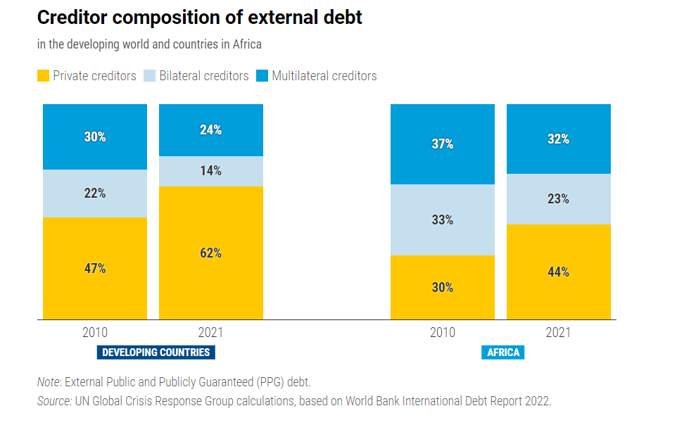

<https://unctad.org/publication/world-of-debt/regional-stories>

The increase in private creditors has meant that borrowing terms and conditions are more stringent and policy space is heavily restricted with objective to keep creditworthiness a central theme in policy making across Africa over the past decade. In addition to the constrained policy space, domestic legislation and policy frameworks governing borrowing and lending have not kept apace with rate of increase in borrowing from international capital markets. The need to maintain creditworthiness via credit ratings has forced African governments to prioritise debt servicing over investment in public services such as education and health. Every dollar Africa spends on debt servicing has an intergenerational impact on girls and women’s political, economic, and social attainment in society. According to the United Nations on Trade and Development (UNCTAD), between 2010 to 2021, in Africa, interest payments have increased by 132% at the detriment of spending on education, healthcare and investment.[5] As a consequence, today, in Africa, close to half the continent spends more on debt interest payments than on education, health, and public investment. (See figure 2 below).

**Figure 2**

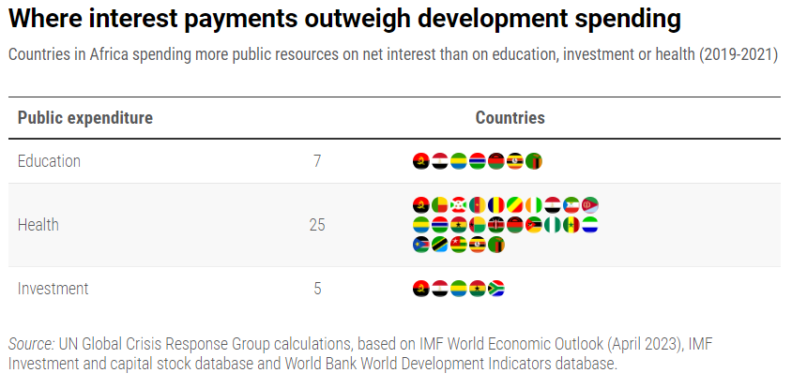

<https://unctad.org/publication/world-of-debt/regional-stories>

***The Feminist Lens to Africa’s Debt challenge[6]***

A [feminist lens in a discussion of debt](https://drive.google.com/file/d/1Mw2pXCVshRls-qxEw9fRn8pwyUUpKQsC/view)[7] is essential  to understanding the macro-economic dimension of gender inequalities,  as well as microeconomic implications, which are shaped and reproduced  by historical, social, political processes. Feminist economists have long critiqued the abstraction of economic policies from their complex social relations and contexts. As orthodox economic policy is based on aggregates, a general presumption is that both policy objectives (such as price stability, employment generation or external balance) and the traditional policy instruments of macroeconomics (fiscal, monetary, exchange rate policies) are gender-neutral, rational and objective. Debt contracts “may be conceived of as largely impersonal, rational, voluntary financial market agreements drawn up between self-interested…agents”.[8] Thus debt contracts are seen in the abstraction and separable to the historical, social, political, and economic relations of actual humans that are set on predicated on a set of distributive relations across different social groups, and they entail distributive choices across various social groups.[9]

**Box 2**

The Pan-African movement spanned the 20th century ideological spectrum, ranging from more right-wing, pro-capitalist, race-based nationalism to more revolutionary socialist discourses advanced by men like George Padmore, Walter Rodney, Kwame Nkrumah, Julius Nyerere, Amilcar Cabral, Stephen Bantu Biko and Frantz Fanon, all of whom locate Africa’s underdevelopment in capitalism, challenging the class system, racism and in the case of Fanon in particular, race-based nationalism. Yet an accurate historic record must include women like Mable Dove Danquah, Adelaide Caseley-Hayford, Bibi Titi Mohamed, Funmilayo Ransome Kuti, Gambo Sawaba, Muthoni Likimani, Thenjiwe Mtintso, Djamila Bouhired, Charlotte Maxeke, Albertina Sisulu, and the other uncounted numbers of women who mobilised for Africa’s liberation.

***Feminist Africa, Issue 19, 2014. Pan Africanism and Feminism***

<http://www.agi.ac.za/sites/default/files/image_tool/images/429/feminist_africa_journals/archive/19/fa_19_web.pdf>

The privatisation or financialisation of development has given rise to complex models of finance at the macro (debt), micro (credit), and individual (microcredit). At each of these levels, the idea of credit or access to credit is at the core. In a social construct where women and girls are structurally marginalised from accessing credit for a myriad of socio-economic reasons, the emergence of microfinancing is one form credit which has been made accessible to women]to much trepidation. This microeconomic model is consistent with the neoliberal discourse that privileges the individualistic, self-help and market-affirming policies that traps the few assets owned by women used as collateral for accessing these credit lines.

The shift to market-based economies within developing countries has led to increasing dependence on money and credit. Feminists have put  forward that debt has become “a mechanism of coercion to accept any  working conditions, due to the fact that the financial obligation ends up  “commanding” labour in the present”.[10] They further argue that “debt  functions and spills over into territories as a compulsive mechanism for  submission to precarisation (conditions, times, and violences of labour),  morally reinforced as an economy of obedience”.[11]With the globalisation  of the 1980s-1990s there has been a transformations in women’s integration in the  global economy – feminisation of labour, labour-intensive and export oriented industries, global care chains. Since the late 1990s, there has been concerted efforts to feminise the labour force through neoliberal policies which has been characterised by working poverty wages and poor working conditions due to the deregulation of the labour market policies.[12] Most employment in Africa, particularly where women are located, is still in precarious, informal, and low productivity work. The African region has the highest level of informal employment at 86%.[13]

A [conscious feminist position](https://drive.google.com/file/d/1hxucN8wH4orOZxjQSpeCB8jK7ZusxOyJ/view)[14] can be challenging, because feminist economics lays the original sin on the existence of capitalism and its debilitating conditions, citing that capitalism thrives on structural inequalities.[15] The African feminist economist Professor Lyn Ossome says, on this matter, that access to land and the commons for the masses, in this context, is much more about day-to-day survival than anything else, arguing that the social reproduction of these survival conditions contributes to the economic non-progress of both rural and urban populations living in poverty. The Addis Ababa Declaration on Population and Development beyond 2014 articulates this proposition explicitly (see box 3).

**Box 3**

**Addis Ababa Declaration on Population and Development beyond 2014**

1. Review, revise, amend or abolish all laws, regulations, policies, practices and customs that have discriminatory impact on women, youth, especially girls, without distinction of any kind, and ensure that the provisions of multiple legal systems comply with international human rights regulations and laws.
2. Increase and enhance the equal participation of women, especially those living in rural areas, in high added value production by increasing their equal access to training and decent work, including, equal pay for equal work, access to social security, paid parental leave, sick and care leave, and other socio-economic benefits, through the design and implementation of gender sensitive budgets with full accountability.
3. Enact and implement laws and introduce institutional reforms to ensure economic empowerment of women and young people through equal access to ownership and control of economic resources, technology and markets, including land, property and inheritance rights.
4. Increase and enhance women’s and youth’s participation in decision-making and leadership positions at all levels through effective implementation of appropriate policies, programmes and affirmative action.

<https://www.unfpa.org/sites/default/files/resource-pdf/addis_declaration_english_final_e1351225_1.pdf>

***The Power Dynamics of Africa’s Debt Challenge***

***“Humanity confronts a great dilemma: to continue the path of capitalism, dadepredation, and death, or to choose the path of harmony with nature and respect for life.” Peoples’ Agreement of Cochabamba, April 2010.***

The status and role of women on the African continent is key to any gains and are elaborated by the synergistic existence of African Union (AU) protocols, and some that stand out. The Maputo Protocol[16], with its focus on women’s rights specifically Article 13 (see box 4) on economic and social welfare rights recognises current barriers to women’s enjoyment of equity in this regard and outlines strategies to promote women’s equal opportunities in work and career advancement and other economic opportunities.[17] The agricultural sector accounts for the work done by most of the continent’s population, with 80 per cent of this farming is done by smallholders[18], many of whom are women.[19] The 2003 Maputo Declaration on Agriculture and Food Security in Africa[20], which states an intention to allocate at least a tenth of national budgets to the sector in recognition of the urgent needs therein, as well as the vulnerabilities and resultant crises.[21] In addition, the [2014 Malabo Declaration](https://www.resakss.org/sites/default/files/Malabo%20Declaration%20on%20Agriculture_2014_11%2026-.pdf), also cites the need for Africans, especially women, to both participate and gain from any growth and development opportunities afforded by agricultural practices on the continent.

Despite the well-articulated protocols and declarations adopted by African Union Member states promoting the advancement of women and girls, the continents’ performance towards gender equality across all facets of life remain low as shown in figures 3 and 4. Women face several obstacles to participating in political and economic life.[22] Structural barriers through discriminatory laws and institutions still limit women’s options to run for office. Capacity gaps mean women are less likely than men to have the education, contacts and resources needed to become effective leaders. Women are underrepresented as voters, as well as in leading positions, whether in elected office, the civil service, the private sector or academia. This occurs despite their proven abilities as leaders and agents of change, and their right to participate equally in democratic governance.

**Box 4**

**PROTOCOL TO THE AFRICAN CHARTER ON HUMAN AND PEOPLES’ RIGHTS ON THE RIGHTS OF WOMEN IN AFRICA**

Article XIII

ECONOMIC AND SOCIAL WELFARE RIGHTS States Parties shall adopt and enforce legislative and other measures to guarantee women equal opportunities in work and career advancement and other economic opportunities. In this respect, they shall:

1. Promote equality of access to employment.
2. Promote the right to equal remuneration for jobs of equal value for women and men.
3. Ensure transparency in recruitment, promotion and dismissal of women and combat and punish sexual harassment in the workplace.
4. Guarantee women the freedom to choose their occupation and protect them from exploitation by their employers violating and exploiting their fundamental rights as recognised and guaranteed by conventions, laws and regulations in force.
5. Create conditions to promote and support the occupations and economic activities of women, in particular, within the informal sector.
6. Establish a system of protection and social insurance for women working in the informal sector and sensitise them to adhere to it.
7. Introduce a minimum age for work and prohibit the employment of children below that age, and prohibit, combat and punish all forms of exploitation of children, especially the girl-child.
8. Take the necessary measures to recognise the economic value of the work of women in the home.
9. Guarantee adequate and paid pre- and post-natal maternity leave in both the private and public sectors.
10. Ensure the equal application of taxation laws to women and men.
11. Recognise and enforce the right of salaried women to the same allowances and entitlements as those granted to salaried men for their spouses and children.
12. Recognise that both parents bear the primary responsibility for the upbringing and development of children and that this is a social function for which the State and the private sector have secondary responsibility.
13. Take effective legislative and administrative measures to prevent the exploitation and abuse of women in advertising and pornography.

The low participation of women in political life can be attributed to the slow advancement of the provisions in Article 13 of The Maputo Protocol of 2003 and several others. As figure 4 and table 1 illustrate the proportion of women in parliament across Africa is on average below 50 percent. The implication of this is that laws and frameworks for advancing women’s and girls’ rights are likely to be ignored and undermine their advancement in society. Moreover, data compiled data by [UN Women show that women represent 23.3 per cent of Cabinet members heading Ministries, leading a policy area as of 1 January 2024](https://www.unwomen.org/sites/default/files/2024-06/Poster-Women-political-leaders-2024-en.pdf).[23]

There are only 15 countries in which women hold 50 per cent or more of the positions of Cabinet Ministers leading policy areas.[24] The five most held portfolios by women Cabinet Ministers are Women and gender equality, followed by Family and children affairs, social inclusion and development, social protection and social security, and Indigenous and minority affairs.[25] These statistics show in plain view the power dynamics and asymmetries that continue to persist in politics and running of government. And this has a knock-on effect of how macroeconomic policy is designed with the objective of advancing the political, economic, and social mobility of women and girls.

As the 2011 UN General Assembly [resolution on women’s political participation](https://www.un.org/ga/search/view_doc.asp?symbol=A/RES/66/130) notes, “Women in every part of the world continue to be largely marginalised from the political sphere, often as a result of discriminatory laws, practices, attitudes and gender stereotypes, low levels of education, lack of access to health care and the disproportionate effect of poverty on women.” As of 1 June 2024, there are 27 countries where 28 women serve as Heads of State and/or Government[26] At the current rate, gender equality in the highest positions of power will not be reached for another 130 years.[27]

**Figure 3** [**African gender inequality in numbers**](https://www.uneca.org/gender-equality-and-empowerment-women)**[28]**

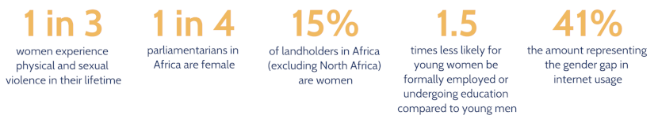

|  |  |  |  |
| --- | --- | --- | --- |
| **Table 1:**  The regions in the table below are listed by percentage of seats held by women in lower and single chambers as of **1st June 2024** | | | |
| Region | Lower Chamber and Unicameral | Upper Chamber | All Chambers |
| East Africa | 32.20% | 30.00% | 32.00% |
| Southern Africa | 31.30% | 35.50% | 31.70% |
| Central Africa | 23.30% | 27.00% | 24.20% |
| West Africa | 19.10% | 13.10% | 18.50% |
| North Africa | 17.00% | 8.40% | 15.10% |
| <https://data.ipu.org/women-averages/?date_month=1&date_year=2024> | | | |

**Figure 4[29] Sustainable Development Report 2024: SDG 5: Seats Held by Women in National Parliament as a %**

<https://dashboards.sdgindex.org/map/indicators/seats-held-by-women-in-national-parliament>

“The financing gap for the Sustainable Development Goals (SDGs) stands at $1.3 trillion per year. … Africa needs at least an additional $800 million per year towards meeting the SDGs. At the current pace, gender equality will only be achieved in 2094,” [according to William Muhwava](https://www.uneca.org/stories/women%2C-girls-in-focus-as-au%2C-sadc-stress-financing-gender-data-for-development), Chief of the Demographic and Social Statistics Section. From the local to the global level, women’s leadership and political participation are restricted [30] and needs to be addressed urgently if we are to reduce this timeline significantly.

1. **Conference Pillars**
   1. **Political –** this pillar is about the ideological and philosophical framing of alternative approaches to the Africa’s emancipation and manifest destiny. At AfCoDD IV, the Feminist approach will be framed toward a focus on people, not just for demographic reasons that highlight gender, but also positioning humans as beings with agency, whose decisions are responsive to and informed by their environments and circumstances in ways that already speak to the barriers they face, what they have been taught, their experiences and what they want for their future.
   2. **Research and Ideation –** This pillar is about contributing to the Pan-African knowledge and intellectual perspectives of feminist lens on debt, the debt crisis, development finance, and structural transformation of Africa. A journal of selected papers for presentation will be launched at the AfCoDD.
   3. **Public Mobilisation #SisiNdioTuko –** This pillar is about national civic movement building in a sustained manner beyond the current debt crisis.
2. **Objectives**

AfCoDD IV is framed around the need to build a distinctly African feminist debt agenda to:[31]

1. Reflect on, describe and respond to Africa’s separate cultural, social, economic and geopolitical landscapes and the diversity of our realities
2. Continue building African feminist discourse and produce knowledge that is our own and that underscores and documents our experience and agency
3. Deconstruct and reconstruct necessary to centre Africa and its people and reclaim our humanity and dignity
4. **Conference Format, Dates and Venue**

The AfCoDD will be held over 3 days between 28th and 30th August 2024 in Maputo, MOZAMBIQUE. It will be held in-person and livestreamed on all our social media platforms. For more information, please contact John Oduk [john@afrodad.org](mailto:john@afrodad.org), Vanessa Jarava [vanessa@afrodad.org](mailto:vanessa@afrodad.org), and Aurore Sokpoh [eventscoordinator@afrodad.org](mailto:eventscoordinator@afrodad.org)

-END-

**About the AfCoDD IV Convenors**

[**African Forum and Network on Debt and Development (AFRODAD)**](http://www.afrodad.org)

AFRODAD is concerned with ensuring that the African continent does not slide back into being heavily indebted and is focused on influencing African governments to institute and implement policies and practices for sustainable development and eradication of poverty through development and implementation of sustainable debt policies; transparent, accountable and efficient mechanisms for mobilisation and utilisation of domestic resources; and effective use of international public finance. Our mission is to Contribute to Africa's inclusive economic growth and sustainable development through influencing policy change on debt management and development finance anchored on rights-based approaches.

[**NAWI Afrifem Collective (Nawi Collective)**](https://www.nawicollective.org/)

The Nawi Afrifem Collective (Nawi Collective) is an African Feminist Political Economy collective founded in 2020 with the purpose of building a community of African feminists and organizations working on influencing, analysing, deconstructing and reconstructing the political economy. As African Feminists, they work to “reclaim the rich histories of Black [women] in challenging all forms of domination, in particular as they relate to patriarchy, race, class, sexuality and global imperialism” in the context of macro-level economic systems.

[**Centre for Democracy and Human Rights (CDD)**](https://cddmoz.org/)

[**The Stop the Bleeding Campaign (STBc)**](https://afrodad.org/campaigns/stop-the-bleeding-campaign)

The Stop the Bleeding Campaign (STBc) is a CSO founded movement bound by a shared vision of African citizens living with dignity in a just, integrated and prosperous Africa. Members of the STBc include [the African Forum and Network on Debt and Development (AFRODAD)](http://www.afrodad.org); [Africa Women’s Development and Communication Network (FEMNET)](https://www.femnet.org/); [International Trade Union Confederation Africa (ITUC Africa)](https://ituc-africa.org/); [Pan African Lawyers Union](https://lawyersofafrica.org/) (PALU); [Tax Justice Network Africa](https://taxjusticeafrica.net/) (TJNA); [Nawi – Afrifem Macroeconomics Collective](https://www.nawi.africa/) (Nawi Collective); and [Trust Africa](https://www.trustafrica.org/en/) (TA).

1. Nawi <https://drive.google.com/file/d/1b3fnZ2zaT-KdxF6AAcQp0gH4P5QPBZqk/view>
2. <https://www.uneca.org/sites/default/files/Gender/eca-fast-facts_women-leadership-and-political-participation.pdf>
3. Based on calculations and data from the IMF and World Bank
4. <https://drive.google.com/file/d/1b3fnZ2zaT-KdxF6AAcQp0gH4P5QPBZqk/view>
5. UNCTAD 2022 <https://unctad.org/publication/world-of-debt/regional-stories>
6. This section relies heavily on the work of our co-convenor, Nawi Afrifem Macroeconomics Collective
7. Busi Sibeko <https://drive.google.com/file/d/1Mw2pXCVshRls-qxEw9fRn8pwyUUpKQsC/view>
8. Nelson, J. 2006. Ethics and International Debt: A View from Feminist Economics. Global Development and Environment Institute. Working paper NO. 06-04 Available [Online]: <https://www.bu.edu/eci/files/2020/01/06-04EthicsDebt.pdf>
9. Sibeko, B, Phalatse, S & Ossome, L. (2021). Feminist Proposals on Macroeconomic

   Policies needed for a COVID-19 Economic Recovery. Available [Online]:

   <https://www.iej.org.za/wp-content/uploads/2021/06/FeministMacroeconomicPolicies-Briefing.pdf>
10. Cavallero, L; & Gago, V. 2020. 10 Theses on Feminist Economics (or the antagonism between the strike and finance). CLCWeb: Comparative Literature and Culture. Available [Online]: <https://docs.lib.purdue.edu/cgi/viewcontent.cgi?article=3845&context=clcweb>
11. Cavallero, L; & Gago, V. 2020. 10 Theses on Feminist Economics (or the antagonism between the strike and finance). CLCWeb: Comparative Literature and Culture. Available [Online]: <https://docs.lib.purdue.edu/cgi/viewcontent.cgi?article=3845&context=clcweb>
12. Standing, G. 1999. Global Feminization Through Flexible Labor: A Theme Revisited. Available [Online]: [http://www.brooklyn.cuny.edu/web/aca_socialsciences_polisci/150422_ IA_Comps_StandingGlobal-Feminization-Through-Flexible-Labor.pdf](http://www.brooklyn.cuny.edu/web/aca_socialsciences_polisci/150422_%20IA_Comps_StandingGlobal-Feminization-Through-Flexible-Labor.pdf)
13. According to the ILO, even though SDG indicator 8.3.1 refers to the proportion of informal employment in non-agricultural employment, the incidence of informality in agriculture may be large in some countries. Thus, in order to have a comprehensive picture of workers’ working conditions and the overall extent of informality, especially in developing and emerging countries, indicator 8.3.1 should be supplemented by other measures of informality covering the whole economy (agriculture and non-agriculture).
14. Njoki Ngumi <https://drive.google.com/file/d/1hxucN8wH4orOZxjQSpeCB8jK7ZusxOyJ/view>
15. Shukla, A. (2021). Feminism and Capitalism: The Ideological Dilemma of Co-existence. Feminism In

    India. <http://bit.ly/3EJTuYG>
16. <https://au.int/sites/default/files/treaties/37077-treaty-charter_on_rights_of_women_in_africa.pdf>
17. (1995). The Maputo Protocol. United Nations Human Rights Office of the High Commissioner.

    <http://bit.ly/3UNW0D6>
18. *Ibid*
19. Abass, J. (2018). Women Grow 70% of African’s Food. But They Have Few Rights Over the Land They Tend. World Economic Forum. http://bit.ly/3AszaIK
20. <file:///C:/Users/Maureen/Downloads/CAADP_Maputo%202003.pdf>
21. (2003). The Maputo Declaration. Scaling Up Nutrition. <http://bit.ly/3tGjSwe>
22. <https://www.unwomen.org/sites/default/files/2024-06/Poster-Women-political-leaders-2024-en.pdf>
23. <https://www.unwomen.org/en/what-we-do/leadership-and-political-participation/facts-and-figures#_edn4>
24. <https://www.unwomen.org/en/what-we-do/leadership-and-political-participation/facts-and-figures#_edn5>
25. <https://www.unwomen.org/en/what-we-do/leadership-and-political-participation/facts-and-figures#_edn6>
26. <https://www.unwomen.org/en/what-we-do/leadership-and-political-participation/facts-and-figures#_edn1>
27. <https://www.unwomen.org/en/what-we-do/leadership-and-political-participation/facts-and-figures#_edn2>
28. UNECA <https://www.uneca.org/gender-equality-and-empowerment-women>
29. Sustainable Development Report 2024 <https://dashboards.sdgindex.org/map/indicators/ratio-of-female-to-male-labor-force-participation-rate>
30. UN Women <https://www.unwomen.org/en/what-we-do/leadership-and-political-participation/facts-and-figures#83879>
31. Aligned with the aspirations outlined by Nawi-Afrifem Macroeconomic Collective